Reference :
https://youtu.be/dpUWV0EY5PI?si=JKC2IirX40P7lsT0
17/04/2026

OOPS :
OOP stands for Object-Oriented Programming. It is a way of writing code by organizing it around objects that contain both data and behavior, which makes programs easier to reuse, maintain, and understand.
Core ideas
- Class: a blueprint for creating objects. For example, Car is a class.
- Object: an actual thing made from a class, like myCar.
- Data/fields: the properties of an object, such as color or speed.
- Methods: the actions an object can perform, such as start() or brake().

Four pillars
- Encapsulation: keep data and methods together in one unit, and control access to data.
- Inheritance: one class can reuse features of another class, which improves code reuse.
- Polymorphism: one action can behave differently in different situations; this is one of the main OOP ideas commonly taught in Java OOP courses.
- Abstraction: show only the important features and hide the internal details.

Why OOP is useful
- It makes code modular.
- It improves reusability.
- It helps manage large projects.
- It maps well to real-world entities.
Simple example
Think of a Car:
- Class: Car
- Object: ToyotaCar
- Data: color, model, speed
- Methods: start(), stop(), accelerate()

How to create a class:
Use the class keyword:

class Car {
String color;
void drive() {
System.out.println("Car is driving");
}
}

This defines a Car class with one field and one method.

How to create an object:
Car myCar = new Car();
Here:
- Car is the class name.
- myCar is the object name.
- new Car() creates the object in memory.

Simple example

class Car {
String color = "Red";
void drive() {
System.out.println("Driving");
}
public static void main(String[] args) {
Car car1 = new Car();
System.out.println(car1.color);
car1.drive();
}
}
In this example, car1 is an object of the Car class, and it can access the class’s fields and methods.
Easy memory trick
- Class = plan
- Object = thing made from the plan
So if Car is the plan, then car1 and car2 are objects made from it.

****In programming
In OOP, binding usually means connecting a method call to the code that will run. This can happen at compile time or runtime, depending on the language and the type of binding being discussed.
A simple example: when you call a method like draw(), the program decides which version of draw() to use. That decision is called binding.

An access modifier is a keyword that controls where a class, method, variable, or constructor can be used in Java and other OOP languages.
Main types in Java
- public:
  - accessible from anywhere.
  - Modify anywhere inside and outside the class
- private:
  - accessible only inside the same class.
  - And can not modify data from the outside class.
  - Can not access the class outside the class without method.
- protected:
  - accessible and modify in the same package and in subclasses.

- default:
  - no keyword; accessible only within the same package.
Simple idea:
Think of access modifiers like security levels:
- public = open to everyone.
- private = only for the owner class.
- protected = family access, meaning subclasses can use it.
- default = shared only inside the same package.

Encapsulation:
Encapsulation is the OOP concept of bundling data and the methods that work on that data into one unit, usually a class. It also means hiding internal data and allowing access only through controlled methods like getters and setters.

Simple meaning
Think of a capsule: the important things are kept inside, and the outside world interacts with it only through the allowed interface. In Java, this is commonly done by making fields private and methods public.

Why it is used
- It protects data from accidental changes.
- It improves code organization.
- It lets you add validation before changing values, like checking age or balance.

class Student {
private String name;
private int age;

public String getName() {
return name;
}

public void setName(String name) {
this.name = name;
}

public int getAge() {
return age;
}

public void setAge(int age) {
if (age > 0) {
this.age = age;
}
}
}

Here, name and age are hidden inside the class, and other code can access them only through methods.
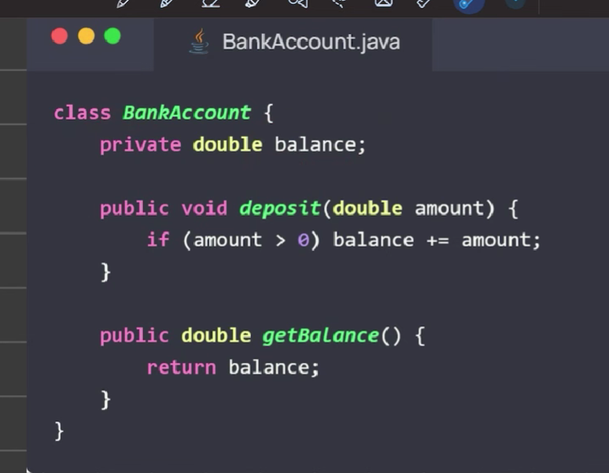

Declaration is creating a variable by telling Java its type and name, while initialization is giving that variable its first value.

Simple example:
int age; // declaration
age = 20; // initialization
int marks = 90; // both declaration and initialization

In the first case, age is declared first and initialized later. In the second case, both happen in one line.

Object example

Date today; // declaration
today = new Date(); // instantiation + initialization
For objects, declaration only creates the reference, and new creates the object and initializes it.
Difference
- Declaration: introduces the variable name and type.
- Initialization: assigns the first value.
- Both together: int x = 10;.

This
keyword in Java refers to the current object. It is used inside instance methods and constructors to access the object’s fields and methods.
Uses of this
- To refer to instance variables when local variables have the same name.
- To call another constructor in the same class using this().
- To pass the current object as an argument.
- To return the current object from a method.
Example
class Student {
int id;

Student(int id) {
this.id = id;
}
}
Here, this.id means the field of the current object, while id is the constructor parameter.

Constructor
A special method used to initialize objects
A constructor in Java is a special block used to initialize an object when it is created. It has the same name as the class and no return type.
Main points
- It runs automatically when you create an object with new.
- It is used to assign initial values to fields.
- A class can have more than one constructor with different parameters.
- If you do not write any constructor, Java provides a default no-argument constructor.
Types of constructors
- Default constructor: no parameters.
- Parameterized constructor: takes values and sets object state.
Example
class Car {
String model;
int year;

Car() {
model = "Unknown";
year = 0;
}

Car(String model, int year) {
this.model = model;
this.year = year;
}

public static void main(String[] args) {
Car c1 = new Car();
Car c2 = new Car("Toyota", 2021);
}
}
In this example, the first object uses the no-arg constructor, and the second uses the parameterized constructor.

Inheritance :
Inheritance is an OOP concept where one class acquires the properties and methods of another class. The class that inherits is called the child/subclass, and the class being inherited from is the parent/superclass.

Simple meaning
Think of it like this: a Vehicle class has common features like start() and stop(), and a Car class can inherit those features instead of writing them again. This makes code more reusable and easier to manage.

Why it is used
- It saves code by reusing existing class features.
- It helps organize code in a logical parent-child structure.
- It lets a child class add its own extra features on top of the parent class.
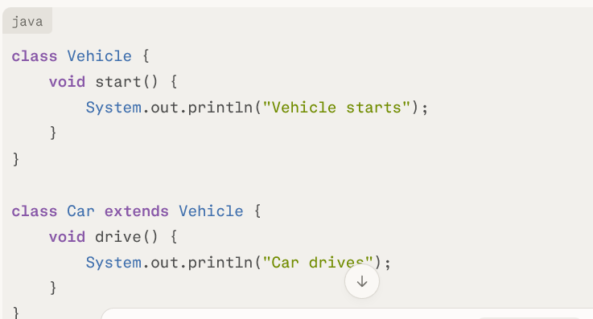
Car inherits start() from Vehicle, and it also has its own drive() method.

One-line exam answer:
Inheritance means one class gets the properties and methods of another class to promote code reuse. Use of extends keyword.

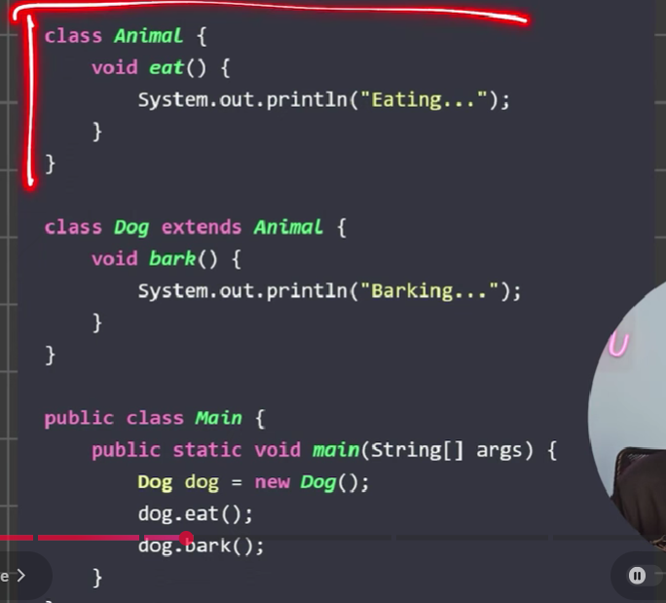

Types of inheritance in Java:
Single inheritance:
means one child class inherits from one parent class only. It is also called simple inheritance.

Easy example
- Animal = parent class.
- Dog = child class.
- If Dog gets features from only Animal, that is single inheritance.
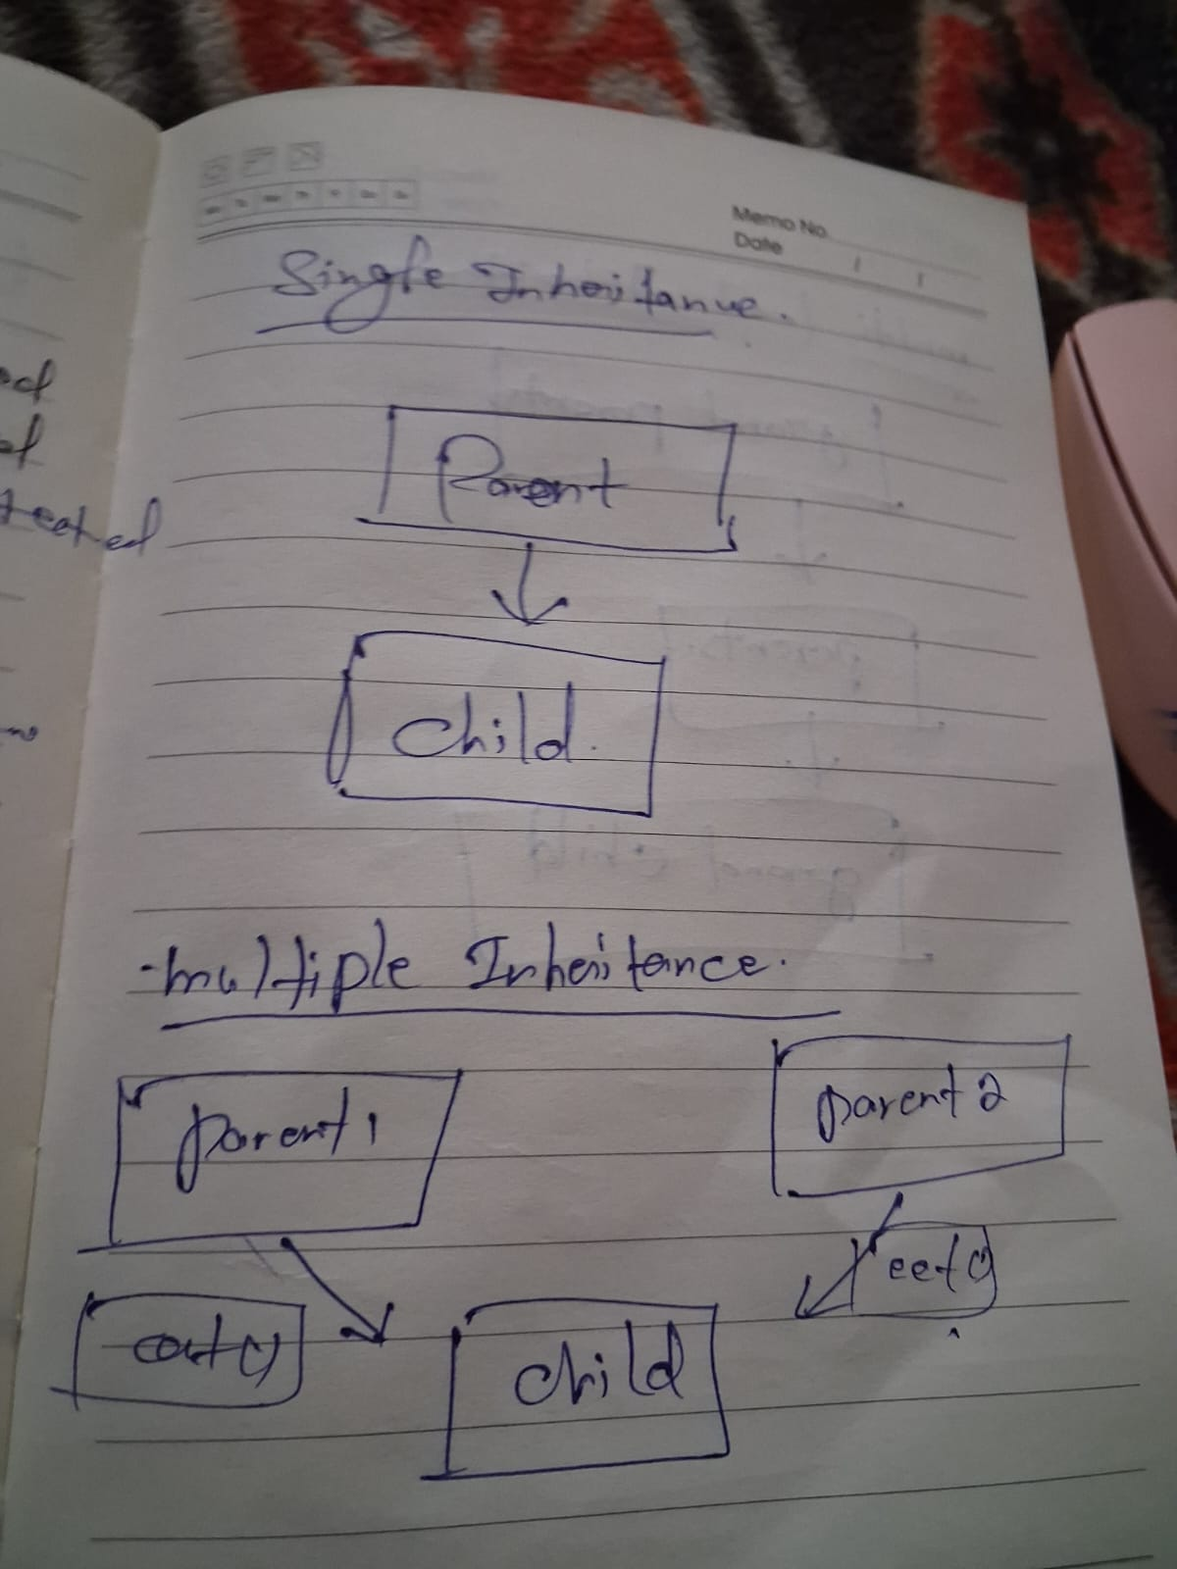

Java example:
class Animal {
void eat() {
System.out.println("Eating");
}
}
class Dog extends Animal {
void bark() {
System.out.println("Barking");
}
}
Here, Dog inherits from only one class, Animal, so this is single inheritance.

Why it is useful
- It reuses code.
- It reduces repetition.
- It makes the class relationship easy to understand.

One-line definition
Single inheritance is when a class inherits properties and methods from only one superclass.

multiple inheritance:
In Java, multiple inheritance of classes is not supported. Instead, Java allows a class to implement multiple interfaces, which gives you a similar result without the ambiguity problem.

Example
interface Father {
void job();
}
interface Mother {
void caring();
}
class Child implements Father, Mother {
public void job() {
System.out.println("Father's trait");
}
public void caring() {
System.out.println("Mother's trait");
}
public static void main(String[] args) {
Child c = new Child();
c.job();
c.caring();
}
}

Output
Father's trait
Mother's trait

Why Java does this
If two parent classes have the same method, Java would not know which one to use. That ambiguity is one reason Java avoids multiple inheritance with classes. Using interfaces lets Java support multiple behavior contracts safely.

Remember
- extends is used for one class only.
- implements is used for one or more interfaces.
- A class can extend one class and implement multiple interfaces.

Multi level inheritance:
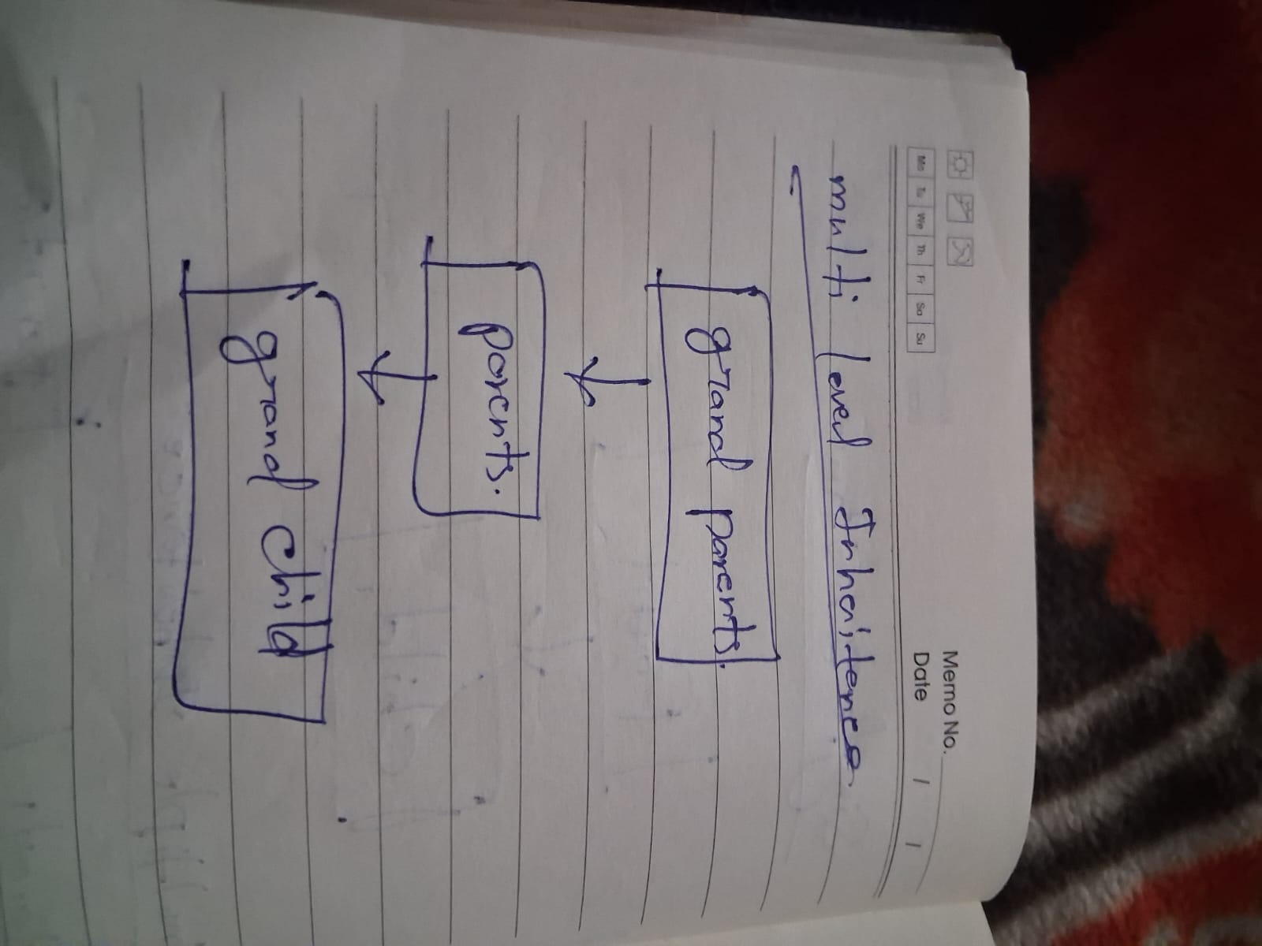
Multilevel inheritance in Java means one class inherits from another class, and that class inherits from a third class, forming a chain like A -> B -> C.

Example
class A {
void showA() {
System.out.println("Class A");
}
}
class B extends A {
void showB() {
System.out.println("Class B");
}
}
class C extends B {
void showC() {
System.out.println("Class C");
}
public static void main(String[] args) {
C obj = new C();
obj.showA();
obj.showB();
obj.showC();
}
}

Output

Class A
Class B
Class C

How it works
- C directly inherits from B.
- B directly inherits from A.
- So C can access members of both B and A through inheritance.

Points to remember
- It uses the extends keyword.
- A child class can also become a parent class for another class.
- It is common in class hierarchies where features are built step by step.

Hierarchical inheritance:
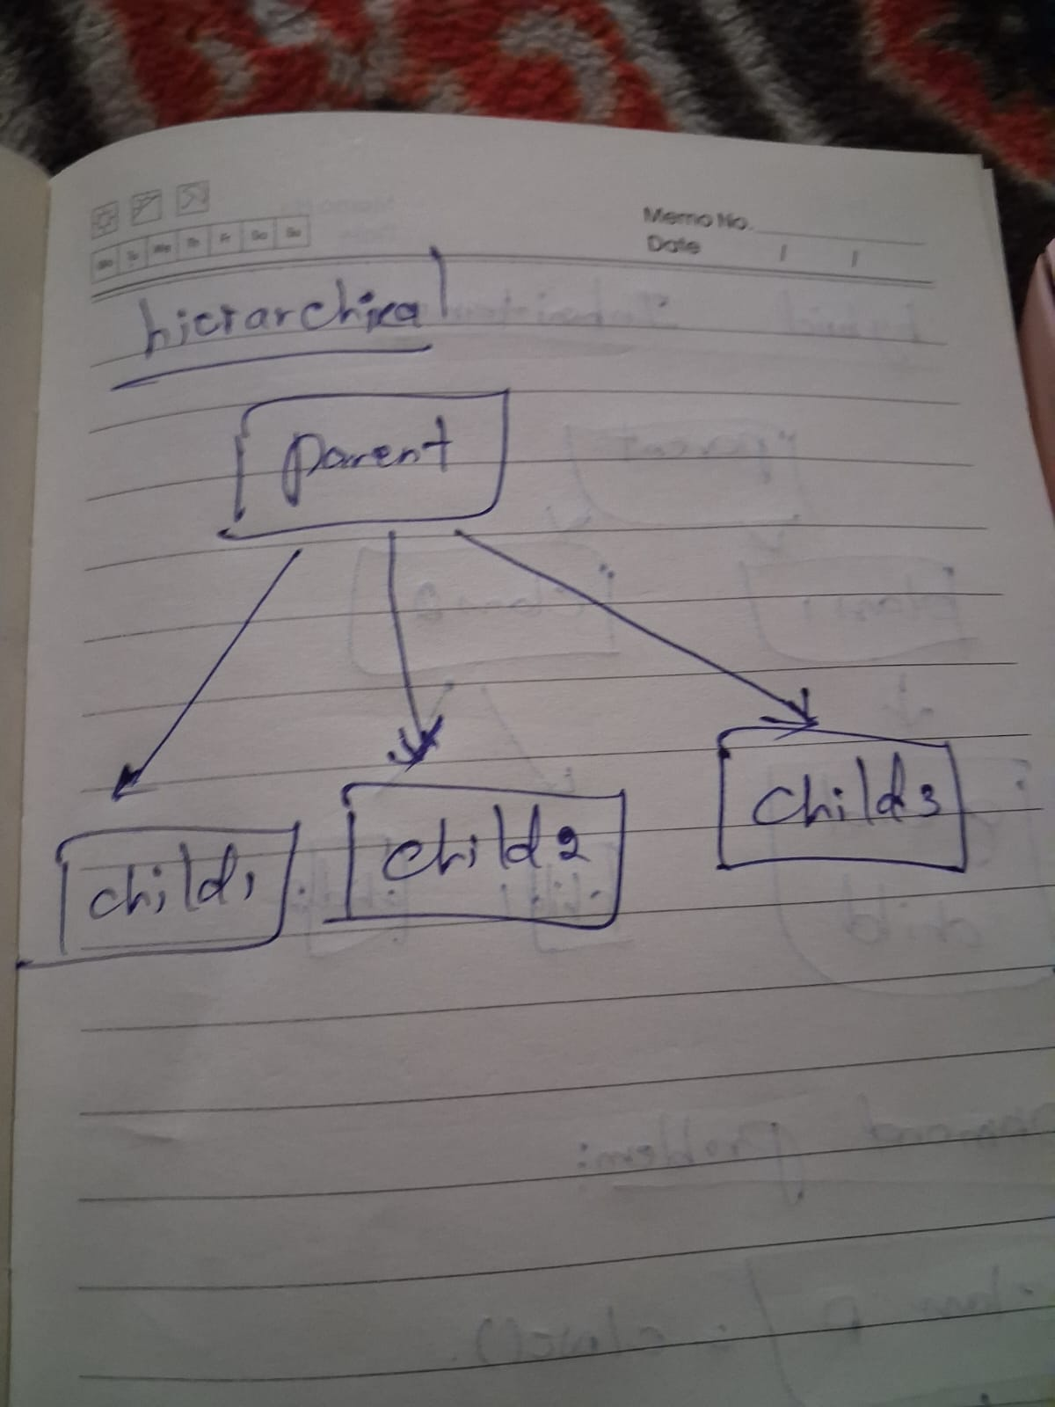
in Java means multiple child classes inherit from the same parent class. It is useful when several classes share common features, but each also has its own special behaviour.

Example
class Animal {
void eat() {
System.out.println("Animals can eat");
}
}
class Dog extends Animal {
void bark() {
System.out.println("Dog barks");
}
}
class Cat extends Animal {
void meow() {
System.out.println("Cat meows");
}
}
public class Main {
public static void main(String[] args) {
Dog d = new Dog();
d.eat();
d.bark();
Cat c = new Cat();
c.eat();
c.meow();
}
}

Output:
Animals can eat
Dog barks
Animals can eat
Cat meows

How it works
- Animal is the parent class.
- Dog and Cat both inherit from Animal.
- Both child classes can use the common eat() method, and each can also have its own methods.

Key point
This is different from multilevel inheritance, where inheritance happens in a chain like A -> B -> C. In hierarchical inheritance, it branches from one parent to many children.

Hybrid inheritance
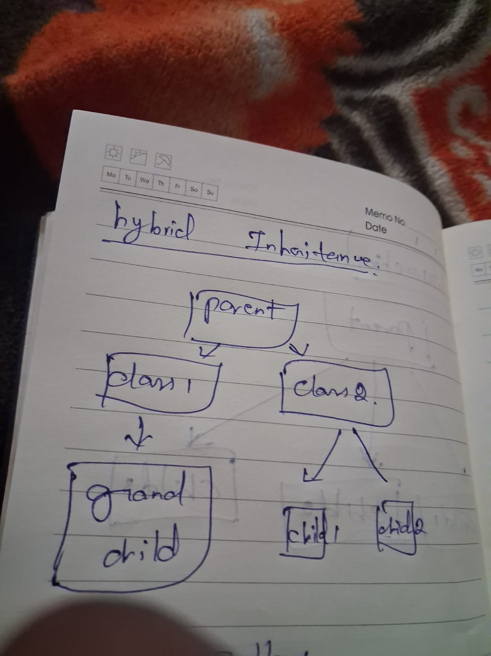
is a combination of two or more inheritance types in one program. In Java, it is usually achieved using classes plus interfaces, because Java does not support multiple inheritance with classes directly.

Example
class Creature {
void exist() {
System.out.println("Creature exists");
}
}
class Bird extends Creature {
void fly() {
System.out.println("Bird flies");
}
}
interface Singer {
void sing();
}
interface Dancer {
void dance();
}
class Nightingale extends Bird implements Singer, Dancer {
public void sing() {
System.out.println("Nightingale sings");
}
public void dance() {
System.out.println("Nightingale dances");
}
public static void main(String[] args) {
Nightingale n = new Nightingale();
n.exist();
n.fly();
n.sing();
n.dance();
}
}

Output

Creature exists
Bird flies
Nightingale sings
Nightingale dances

How this is hybrid
- Bird extends Creature is single inheritance.
- Nightingale extends Bird is part of multilevel inheritance.
- Nightingale implements Singer, Dancer adds multiple inheritance through interfaces.
- Together, this makes it hybrid inheritance.

Important point
Java allows hybrid inheritance safely by using interfaces along with classes, instead of allowing multiple class inheritance directly.

Diamond problem

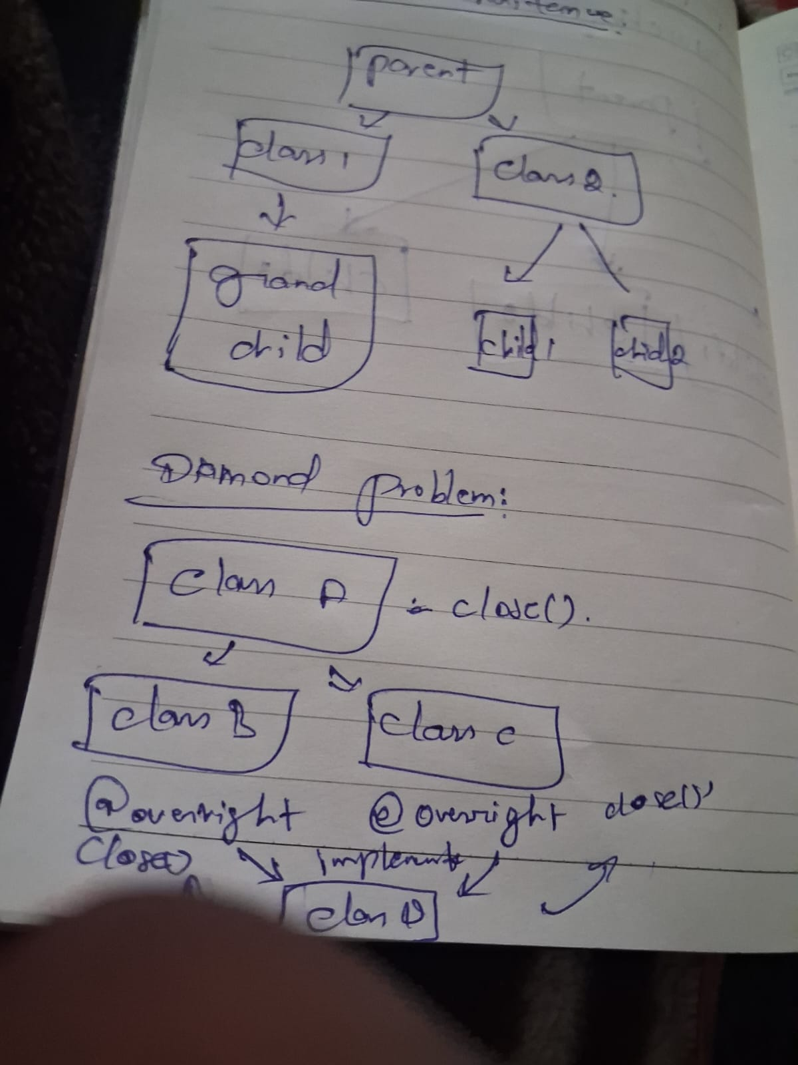


Here’s the example of super in the diamond problem context.
Java class case
Java does not allow multiple inheritance with classes, so the classic diamond problem does not happen there.
java
class A {
void show() {
System.out.println("A");
}
}

class B extends A { }

class C extends A { }

// This is NOT allowed in Java:
// class D extends B, C { }
Because D extends B, C is illegal, Java avoids the ambiguity that would make super confusing.
Interface default method case
Java can still get a diamond-like conflict with interfaces that have the same default method. In that case, the implementing class must resolve the conflict explicitly.
interface B {
default void show() {
System.out.println("B");
}
}

interface C {
default void show() {
System.out.println("C");
}
}

class D implements B, C {
public void show() {
B.super.show();
}
}

In this example, B.super.show() tells Java to use the default method from interface B.

Important point
So, super in a diamond situation is mainly used with interfaces in Java 8+, not with multiple class inheritance, because Java blocks that case entirely.

super.method() overriding:

Here’s a simple super.method() overriding example in Java.

class Parent {
void display() {
System.out.println("Parent class method");
}
}

class Child extends Parent {
@Override
void display() {
super.display(); // calls Parent class method
System.out.println("Child class method");
}
}

public class Main {
public static void main(String[] args) {
Child obj = new Child();
obj.display();
}
}
Output

Parent class method
Child class method

What happens
- Child overrides the display() method of Parent.
- Inside the overridden method, super.display() calls the parent version.
- Then the child version continues and prints its own message.

****Ambiguity means something has more than one possible meaning, so it can be understood in different ways and cause confusion.

is the ambiguity that happens when a class inherits the same method from two paths in an inheritance chain, creating a diamond-shaped structure.
In Java
Java avoids this problem for classes because it does not support multiple inheritance with classes.
However, a similar conflict can happen with interfaces that have default methods, and Java requires the class to resolve it explicitly.

Simple shape
- A is the top parent.
- B and C extend A.
- D extends both B and C.
- If B and C define the same method, D may not know which one to use.

Example idea
interface A {
default void show() {
System.out.println("A");
}
}
interface B extends A {
default void show() {
System.out.println("B");
}
}
interface C extends A {
default void show() {
System.out.println("C");
}
}
class D implements B, C {
public void show() {
B.super.show(); // or C.super.show()
}
}

Key point
In Java, the fix is to override the conflicting method in the child class and choose the version you want

Polymorphism:
means “many forms” In Java, it lets the same method or object behave differently depending on the context. Polymorphism is about the same method or reference behaving differently for different objects.

Types
- Compile-time polymorphism: achieved using method overloading, where methods have the same name but different parameters.
- Run-time polymorphism: achieved using method overriding, where a child class gives its own version of a parent method.

Example

class Animal {
void sound() {
System.out.println("Animal makes sound");
}
}
class Dog extends Animal {
@Override
void sound() {
System.out.println("Dog barks");
}
}
public class Main {
public static void main(String[] args) {
Animal a = new Dog();
a.sound();
}
}

Output

Dog barks

1. Compile-time polymorphism
This is also called method overloading. The method name is the same, but the parameter list is different, so Java decides which method to call at compile time.
class Calculator {
int add(int a, int b) {
return a + b;
}
int add(int a, int b, int c) {
return a + b + c;
}
double add(double a, double b) {
return a + b;
}
public static void main(String[] args) {
Calculator c = new Calculator();
System.out.println(c.add(2, 3));
System.out.println(c.add(2, 3, 4));
System.out.println(c.add(2.5, 3.5));
}
}

2. Run-time polymorphism
This is also called method overriding. A child class provides its own version of a parent class method, and Java decides which method to call at runtime.
class Animal {
void sound() {
System.out.println("Animal sound");
}
}
class Dog extends Animal {
@Override
void sound() {
System.out.println("Dog barks");
}
public static void main(String[] args) {
Animal a = new Dog();
a.sound();
}
}

Difference
- Compile-time: method overloading, decided by the compiler.
- Run-time: method overriding, decided by the JVM during execution.
18/04/2026
Abstraction:
means hiding the internal details and showing only the essential features. In Java, it helps you focus on what an object does rather than how it does it.

In Java, instantiated means a class has been used to create an object, usually with the new keyword. That object is called an instance of the class.
Example:
class Car {
String brand;
}
Car c = new Car(); // Car is instantiated here
Here, Car is the class, and c is the object created from it.
In simple words:
- Class = blueprint
- Instantiation = creating the object from that blueprint
- Instance = the created object

Example
Think of a car:
- You use start(), brake(), and accelerate().
- You do not need to know how the engine or fuel system works internally.

Java example
abstract class Animal {
abstract void sound();
void sleep() {
System.out.println("Sleeping...");
}
}
class Dog extends Animal {
void sound() {
System.out.println("Dog barks");
}
public static void main(String[] args) {
Dog d = new Dog();
d.sound();
d.sleep();
}
}

Output
Dog barks
Sleeping...

Key points
- Abstraction hides complexity.
- It is done using abstract classes and interfaces in Java.
- You can’t to use abstract method directly in the new keyword.
- Abstract methods don’t have any implementations.
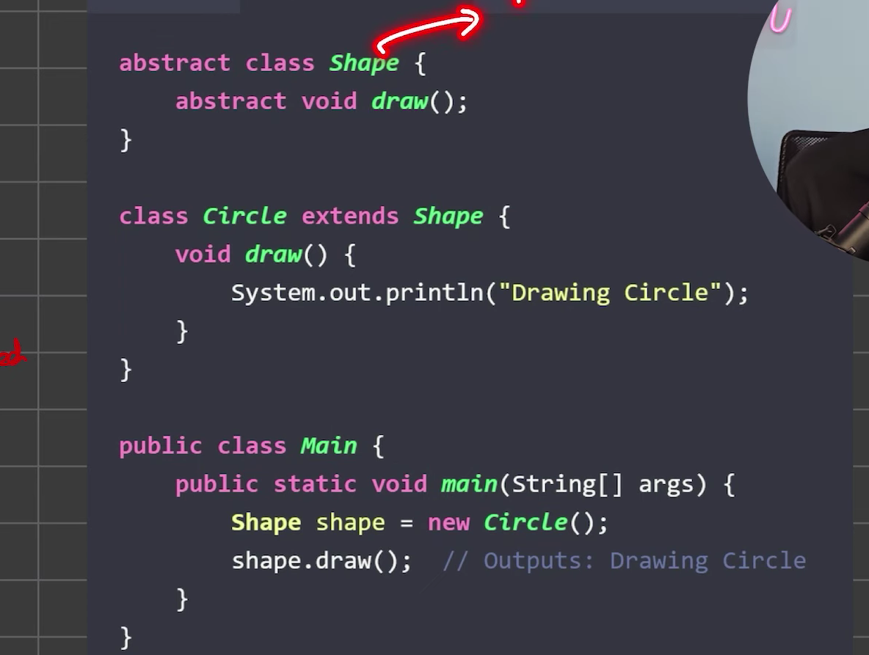

instantiated

No, abstract classes cannot be instantiated directly in Java. An abstract class is incomplete by design, so you must create a subclass and instantiate that subclass instead.
Example:
abstract class Animal {
abstract void sound();
}
class Dog extends Animal {
void sound() {
System.out.println("Bark");
}
}
class Main {
public static void main(String[] args){
Animal a = new Dog();
a.sound();
}
} // valid

Instantiate means to create an object from a class, while initialize means to set the object’s values after or during creation.
Simple difference
- Instantiation = object is created in memory.
- Initialization = object gets its initial values, usually through a constructor or assignments.
Java example
java
Student s1 = new Student("Arun", 21);
In this line:
- new Student(...) instantiates the object.
- "Arun", 21 initializes its fields through the constructor.
Easy way to remember
- Instantiate = make it
- Initialize = set it up

Interface :
An interface in Java is a blueprint that defines a set of methods a class must implement without providing full implementation details. It helps achieve abstraction by focusing on what a class should do rather than how it does it. Interfaces also support multiple inheritance in Java.k
- A class must implement all abstract methods of an interface.
- All variables in an interface are public, static, and final by default.
- Interfaces can have default, static, and private methods (Java 8+ and 9+).
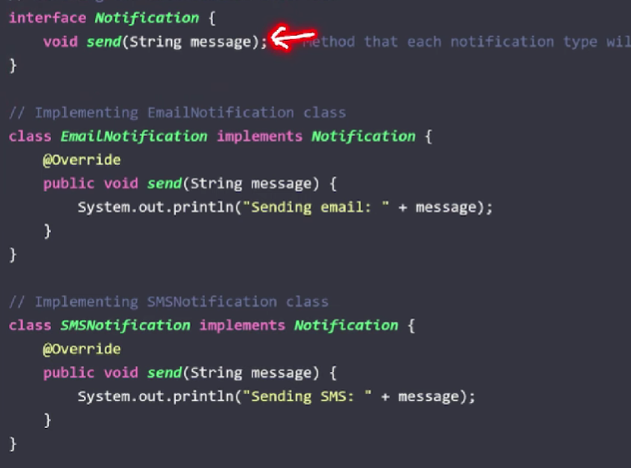

Difference Between Abstract Class and Interface in Java
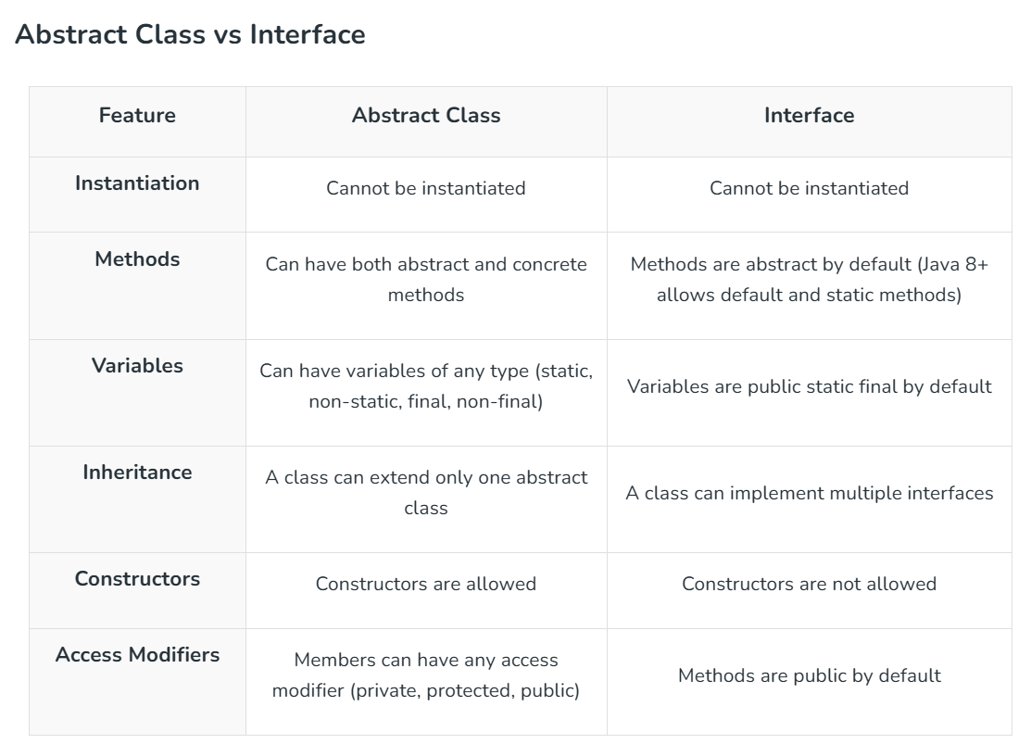

association, aggregation, and composition
Different kinds of object relationships.
Association, aggregation, and composition are three ways to show relationships between classes in Java. Association is the general relationship, aggregation is a weak has-a relationship, and composition is a strong part-of relationship.
Association
Association means one class is related to another class, but both can exist independently. For example, a Teacher and a Student are associated because they interact, but one does not own the other.
Aggregation
Aggregation is a special form of association where one object contains another object, but the contained object can still live on its own. For example, a Department can have Students, and if the department is removed, the students still exist.
Composition
Composition is a stronger form of relationship where one object owns the other, and the child object cannot exist without the parent. For example, a House has Rooms; if the house is destroyed, the rooms no longer matter as separate objects.
Simple difference
- Association: general relationship.
- Aggregation: weak has-a relationship.
- Composition: strong part-of relationship.
Example
java
class Engine { }

class Car {
private Engine engine; // composition

Car() {
engine = new Engine();
}
}
Here, Car creates and owns Engine, so this is composition. If the engine object were passed from outside and could exist independently, that would be aggregation.
example
Completed 2 steps
Here are simple examples for association, aggregation, and composition in Java.
Association example
Java

class Teacher {
String name;
Teacher(String name) {
this.name = name;
}
}

class Student {
String name;
Teacher teacher; // association

Student(String name, Teacher teacher) {
this.name = name;
this.teacher = teacher;
}
}

public class Main {
public static void main(String[] args) {
Teacher t = new Teacher("Ravi");
Student s = new Student("Anu", t);
System.out.println(s.name + " studies with " + s.teacher.name);
}
}
This is association because Student and Teacher are related, but both can exist independently.

Aggregation example
Java

import java.util.*;

class Employee {
String name;
Employee(String name) {
this.name = name;
}
}

class Department {
String deptName;
List<Employee> employees; // aggregation

Department(String deptName, List<Employee> employees) {
this.deptName = deptName;
this.employees = employees;
}
}

public class Main {
public static void main(String[] args) {
Employee e1 = new Employee("Arun");
Employee e2 = new Employee("Karan");
List<Employee> list = new ArrayList<>();
list.add(e1);
list.add(e2);

Department d = new Department("CSE", list);
System.out.println(d.deptName + " has " + d.employees.size() + " employees");
}
}
This is aggregation because Department has Employee objects, but the employees can still exist without the department.
Composition example:

class Engine {
void start() {
System.out.println("Engine started");
}
}

class Car {
private Engine engine; // composition

Car() {
engine = new Engine();
}

void drive() {
engine.start();
System.out.println("Car is moving");
}
}

public class Main {
public static void main(String[] args) {
Car car = new Car();
car.drive();
}
}

This is composition because Car creates and owns the Engine, so the engine’s life depends on the car.
Easy memory trick
- Association = related.
- Aggregation = has-a, but independent.
- Composition = has-a, but dependent.

25/04/2026:
Method overloading vs overriding:
Method overloading
Method overloading means having multiple methods with the same name in the same class, but with different parameters.
Example
class Calculator {
int add(int a, int b) {
return a + b;
}

int add(int a, int b, int c) {
return a + b + c;
}
}
Method overriding
Method overriding means a child class redefines a method of the parent class using the same method name and same parameters.
Example
class Animal {
void sound() {
System.out.println("Animal sound");
}
}

class Dog extends Animal {
@Override
void sound() {
System.out.println("Dog barks");
}
}
Main difference
Feature | Overloading | Overriding
Where it happens | Same class | Parent and child class
Parameters | Must be different | Must be same
Inheritance needed | No | Yes
Polymorphism | Compile-time | Runtime
Purpose | Same name, different behavior with different inputs | Change inherited behavior
Easy memory trick
- Overloading = same name, different parameters.
- Overriding = same name, same parameters, different class behavior.
Interview line
“Method overloading is defining multiple methods with the same name but different parameters in the same class, while method overriding is redefining an inherited method in a subclass with the same signature”.

Constructor overloading and constructor chaining:
Constructor overloading
Constructor overloading means a class has more than one constructor, and each constructor has a different parameter list. It lets you create objects in different ways depending on what values you have.
java
class Student {
String name;
int age;

Student() {
name = "Unknown";
age = 0;
}

Student(String name) {
this.name = name;
age = 0;
}

Student(String name, int age) {
this.name = name;
this.age = age;
}
}
Example
Student s1 = new Student();
Student s2 = new Student("Asha");
Student s3 = new Student("Asha", 21);

Constructor chaining
Constructor chaining means one constructor calls another constructor in the same class, usually using this() . It helps avoid repeated code and keeps initialization in one place.
java
class Car {
String color;
int speed;

Car() {
this("Black", 180);
}

Car(String color) {
this(color, 180);
}

Car(String color, int speed) {
this.color = color;
this.speed = speed;
}
}
How it works
- Car() calls Car("Black", 180).
- Car(String color) calls Car(color, 180).
- Car(String color, int speed) does the actual field assignment.
Main difference
- Overloading = multiple constructors with different parameters.
- Chaining = one constructor calling another constructor.
Important rule
When using this(), it must be the first statement inside the constructor.
Easy interview line
“Constructor overloading means having multiple constructors in the same class, and constructor chaining means calling one constructor from another to reuse code”.

super keyword in inheritance
In inheritance, super is used in a child class to refer to its parent class. It helps you access parent class variables, call parent class methods, and invoke parent class constructors.
Uses in inheritance
- To access a parent class variable when the child class has a variable with the same name.
- To call an overridden method from the parent class.
- To call the parent class constructor using super().

Example
class Animal {
String name = "Animal";

Animal() {
System.out.println("Animal constructor");
}

void sound() {
System.out.println("Animal makes sound");
}
}

class Dog extends Animal {
String name = "Dog";

Dog() {
super();
System.out.println("Dog constructor");
}

void display() {
System.out.println(super.name);
System.out.println(name);
}

void sound() {
super.sound();
System.out.println("Dog barks");
}
}

public class Main {
public static void main(String[] args) {
Dog d = new Dog();
d.display();
d.sound();
}
}
Output idea
- super() calls the parent constructor first.
- super.name accesses the parent variable.
- super.sound() calls the parent method.
Easy interview line
“super is used in inheritance to refer to the immediate parent class and access its constructor, methods, and variables”.

this keyword in constructors and methods
this keyword in Java refers to the current object inside a constructor or method. It is mainly used to avoid confusion between instance variables and local variables, and to call another constructor in the same class.
In constructors
When constructor parameters have the same names as instance variables, this is used to distinguish them.
java
class Student {
String name;
int age;

Student(String name, int age) {
this.name = name;
this.age = age;
}
}
Here, this.name means the object’s field, while name means the constructor parameter.
In methods
Inside a method, this refers to the current object on which the method was called.
java
class Student {
String name = "Asha";

void display() {
System.out.println(this.name);
}
}
Another use in constructors
this() can call another constructor of the same class, and it must be the first statement in that constructor.
java
class Car {
Car() {
this("Black");
}

Car(String color) {
System.out.println(color);
}
}
Easy meaning
- In a constructor, this helps initialize the current object.
- In a method, this refers to the current object calling the method.
- this() is used for constructor chaining.
Interview line
“this keyword refers to the current object and is used in constructors and methods to access instance members, resolve name conflicts, and call another constructor in the same class”.

Interfaces and multiple inheritance through interfaces
Interfaces in Java are used to define a contract that classes must follow, and Java supports multiple inheritance through interfaces by allowing one class to implement more than one interface.
What an interface is
An interface is a blueprint that usually contains method declarations, and a class that implements it must provide the method bodies.
It is useful for abstraction and loose coupling.
Multiple inheritance through interfaces
Java does not support multiple inheritance with classes because it can create ambiguity, but it does support implementing multiple interfaces.
This means one class can get behavior contracts from many interfaces without inheriting conflicting implementation from multiple classes.
Example
interface Printable {
void print();
}

interface Showable {
void show();
}

class Demo implements Printable, Showable {
public void print() {
System.out.println("Printing...");
}

public void show() {
System.out.println("Showing...");
}
}

public class Main {
public static void main(String[] args) {
Demo d = new Demo();
d.print();
d.show();
}
}
Why this is multiple inheritance
- Demo implements Printable.
- Demo also implements Showable.
- So one class inherits multiple types through interfaces.
Why Java allows this
Since interfaces mainly define method contracts, there is no ambiguity about which superclass implementation to use.
That is why Java can safely support multiple inheritance of type through interfaces.
Easy interview line
“Java does not support multiple inheritance with classes, but it supports multiple inheritance through interfaces because a class can implement more than one interface”.

Abstract classes vs interfaces
Abstract classes and interfaces both support abstraction, but they are used differently in Java.
Main difference
- An abstract class can have both abstract methods and regular methods with implementation.
- An interface is mainly a contract; classes implement it to provide behavior.
- A class can extend only one abstract class, but it can implement multiple interfaces.
Easy comparison
Feature | Abstract Class | Interface
Methods | Can have abstract and concrete methods | Mostly abstract methods; can also have default/static methods in modern Java
Variables | Can have instance variables | Variables are usually public static final constants
Constructors | Yes | No
Inheritance | A class can extend only one abstract class | A class can implement multiple interfaces
Use case | For closely related classes with shared code | For unrelated classes that share a capability
Example of abstract class

abstract class Animal {
abstract void sound();

void sleep() {
System.out.println("Sleeping");
}
}

class Dog extends Animal {
void sound() {
System.out.println("Bark");
}
}
Example of interface
interface Flyable {
void fly();
}

class Bird implements Flyable {
public void fly() {
System.out.println("Bird is flying");
}
}
When to use which
- Use an abstract class when classes are closely related and share common code.
- Use an interface when you want to define a capability that many different classes can have.
Simple interview line
“Abstract classes are used when classes share common state or behavior, while interfaces are used to define a contract that different classes can implement; a class can extend only one abstract class but implement multiple interfaces”.

Runtime polymorphism
Runtime polymorphism in Java means the method to be executed is decided at runtime, not compile time. It happens mainly through method overriding and is also called dynamic method dispatch.
Simple idea
When a parent class reference points to a child class object, Java chooses the overridden method of the actual object at runtime.
Example

class Animal {
void sound() {
System.out.println("Animal sound");
}
}

class Dog extends Animal {
@Override
void sound() {
System.out.println("Dog barks");
}
}

public class Main {
public static void main(String[] args) {
Animal a = new Dog();
a.sound();
}
}
Why this is runtime polymorphism
- The reference type is Animal.
- The actual object is Dog.
- At runtime, Java calls Dog's sound() method.
Easy memory line
- Compile-time polymorphism = method overloading.
- Runtime polymorphism = method overriding.
Interview line
“Runtime polymorphism is the process in which a method call is resolved at runtime based on the actual object type, usually through method overriding”.

Upcasting and downcasting
Upcasting is when a child class object is treated as a parent class reference. Downcasting is when a parent class reference is converted back into a child class reference.
Upcasting
Upcasting is usually automatic in Java and is safe because a child object is also a parent object.
class Animal {
void sound() {
System.out.println("Animal sound");
}
}

class Dog extends Animal {
void bark() {
System.out.println("Dog barks");
}
}

public class Main {
public static void main(String[] args) {
Animal a = new Dog(); // upcasting
a.sound();
}
}
Why upcasting is useful
- It supports runtime polymorphism.
- It lets you write flexible code using a parent type.

Downcasting
Downcasting is explicit and converts a parent reference back to a child reference. It is used when you need child-specific methods.
java
class Animal {
void sound() {
System.out.println("Animal sound");
}
}

class Dog extends Animal {
void bark() {
System.out.println("Dog barks");
}
}

public class Main {
public static void main(String[] args) {
Animal a = new Dog(); // upcasting
Dog d = (Dog) a; // downcasting
d.bark();
}
}
Important note
Downcasting is risky if the actual object is not really a child type, because it can cause a ClassCastException.
Difference
Feature | Upcasting | Downcasting
Direction | Child to parent | Parent to child
Casting | Usually automatic | Must be explicit
Safety | Safe | Can be unsafe
Access | Parent members only | Child + parent members
Easy memory trick
- Upcasting = go up the inheritance tree.
- Downcasting = go down the inheritance tree.
Interview line
“Upcasting converts a child reference to a parent reference and is automatic, while downcasting converts a parent reference back to a child reference and requires explicit casting”.

Final keyword with variables, methods, and classes
The final keyword in Java is used to restrict changes. It can be applied to variables, methods, and classes.
1) Final variable
A final variable cannot be reassigned after initialization.

class Test {
final int x = 10;

void show() {
// x = 20; // error: cannot assign a value to final variable
System.out.println(x);
}
}
Meaning
- Once a value is assigned, it stays the same.
- It is often used for constants like PI.
2) Final method
A final method cannot be overridden by subclasses.

class Parent {
final void display() {
System.out.println("Parent display");
}
}

class Child extends Parent {
// void display() { } // error: cannot override final method
}
Meaning
- The method implementation is locked.
- Child classes can use it, but cannot change it.
3) Final class
A final class cannot be inherited.

final class Vehicle {
void run() {
System.out.println("Vehicle is running");
}
}

// class Car extends Vehicle { } // error: cannot inherit from final class
Meaning
- No subclass can extend a final class.
- This is used when the class should not be modified through inheritance.
Easy memory line
- final variable = value cannot change.
- final method = cannot override.
- final class = cannot extend.
Interview answer
“final is a keyword in Java used to restrict modification: a final variable cannot be reassigned, a final method cannot be overridden, and a final class cannot be inherited”.

